**_________________________ ‘s Thesis Outline Template**

**Brainstorm** your research contributions and their thematic buckets:

**Research question or gap:** What is the main question/need/approach that your research touches on?

**Frame a claim** to be argued as a result of your work (or multiple, if you already know!!)

**Sketch your structure**: Sketch the structure of your claim(s). If you have multiple claims, how are they related (if at all)

**Literature Review:**

**Key Areas:** What key topics must be covered for people to understand the gap in the field?

**Establishing the Gap:** What are the weaknesses of current approaches? If you are working in an entirely new field/application, why hasn’t it been done before?

**Methods:**

**Gimme Paragraph:** What is the common description you see other authors writing when they talk about your work? This could be explaining the hardware setup, it could be explaining what a Markov Decision Process is. Repeat this process for each of your independent claims

**Additional Key Areas To Explain:** What other techniques did you use for your research? Write down those key areas here. Repeat this process for each of your independent claims.

**Figures to Explain Your Experimental Set-Up:** Do you have any ideas for figures for your project? If you work in experimental hardware, have you taken photos of your-setup + made any figures to explain the interactions between different parts? If you work in simulation, do you have any figures to explain the inputs and outputs of your simulation and how the output is determined?

**Results:**

**Key Plots:** How can you demonstrate the performance of your work? Do you need to compare your work against others? Once you have results, what do you plan to discuss?

**Discussion Points:** When evaluating each of your key claims, what characteristics do you plan to discuss (i.e. scalability, efficiency, safety, transferability)? These characteristics can be your subheadings within results.

**Conclusion:**

**Summary:** Briefly summarize your entire thesis in 15 words or less.

**Contributions:** Reiterate your main claims, and when you have results, explain them with more detail.

**Discussion:** What are the strengths of your work? What are the key characteristics associated with these strengths? What are the weaknesses? If your results aren’t as strong as you hoped, you can list some of the issues you had during the process as a weakness. List some high level benefits of your approach. List some problems that you’ve had below.

**Future Work:** How can this work be improved? If you could work on this project longer, what else would you do?

**Sign up for our Master’s thesis-focused weekly writing group:**



**https://forms.gle/JB47zcyni5hDXdGK8**

**Possible formattings:**

*1 claim:*

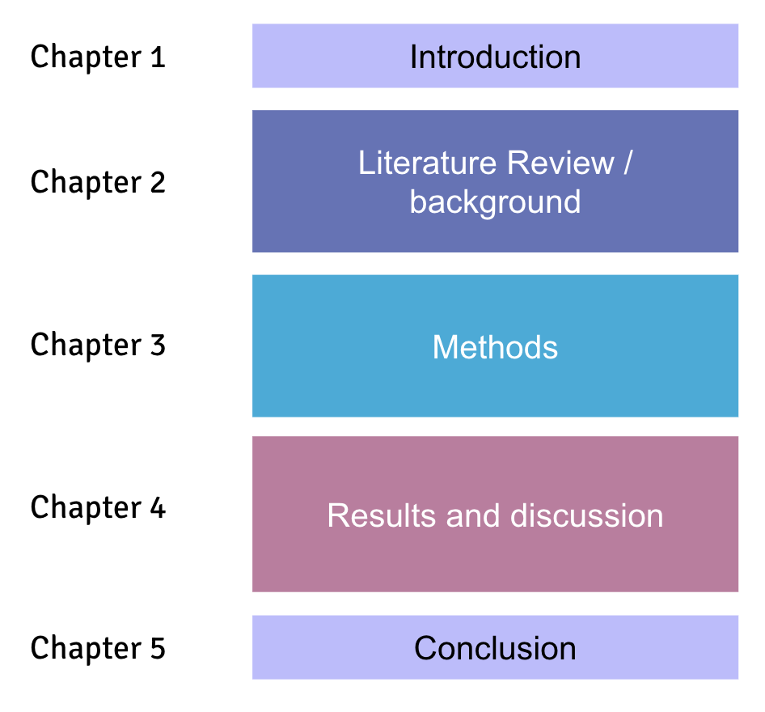

*Multiple claims:*

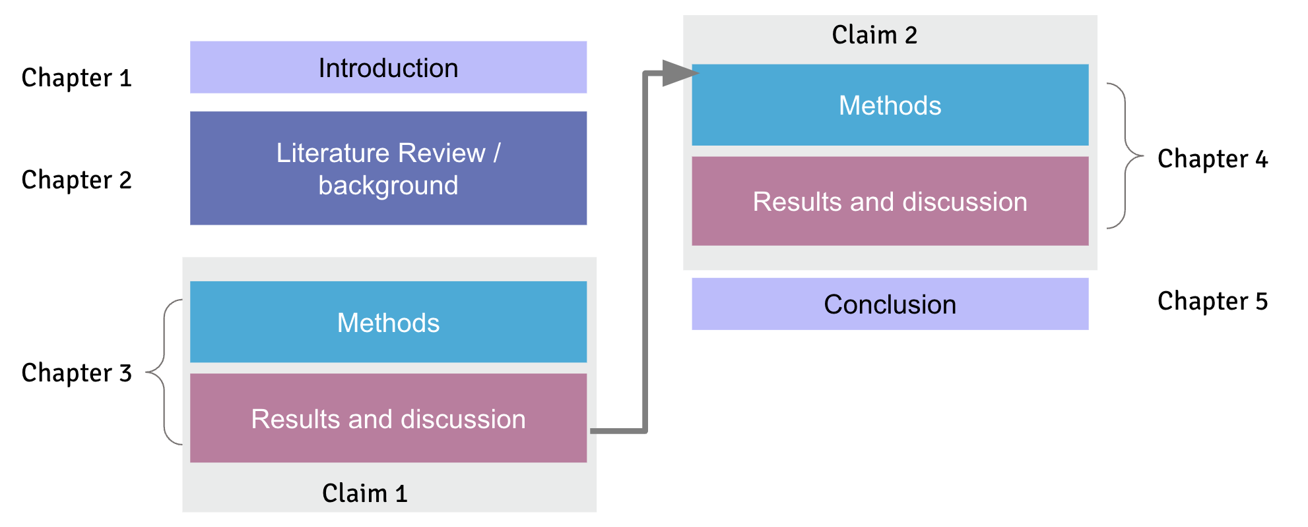

**Alternative example structure:**

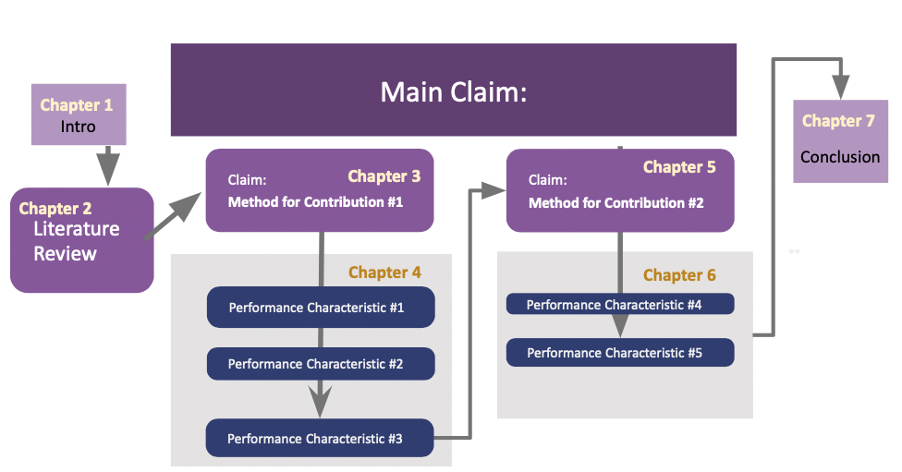

| **Chapter 1: Introduction**   * Main Claim * Key contributions   + - Contribution #1     - Contribution #2   **Chapter 2: Literature Review**   * Key Area #1 * Key Area #2   **Chapter 3: Methods for Key Area #1**   * Gimme Paragraph * Additional Key Areas to Explain   **Chapter 4: Results**   * Contribution #1   + - Performance Characteristic #1     - Performance Characteristic #2     - Performance Characteristic #3 | **Chapter 5: Methods for Key Area #2**   * + Gimme Paragraph   + Additional Key Areas to Explain   **Chapter 6: Results**   * Contribution #2   + Performance Characteristic #4   + Performance Characteristic #5   **Chapter 7: Conclusion**   * Summary   + Contributions * Discussion   + Strengths   + Weaknesses * Future Work |
| --- | --- |